22.05.2023

20 нейронов

1. nn = **20**, n_train = 1000, n_test = 300, k = 0.999, tau_const = 3.5,

g_const = 3.1/ni(train), 3.5/ni(clf), 3.7/ni(test), learning_rate = 0.25

Training time: 92.92725229263306

Actual number of training set: 47

Number of neurons, reacting to the corresponding image: {'4': 2, '2': 2, '5': 4, '9': 1, '7': 3, '0': 4, '6': 2, '1': 1, '8': 1}

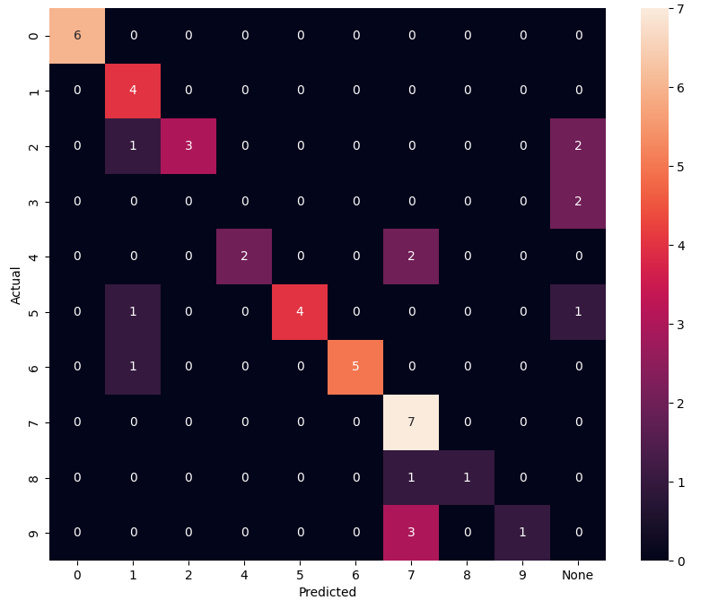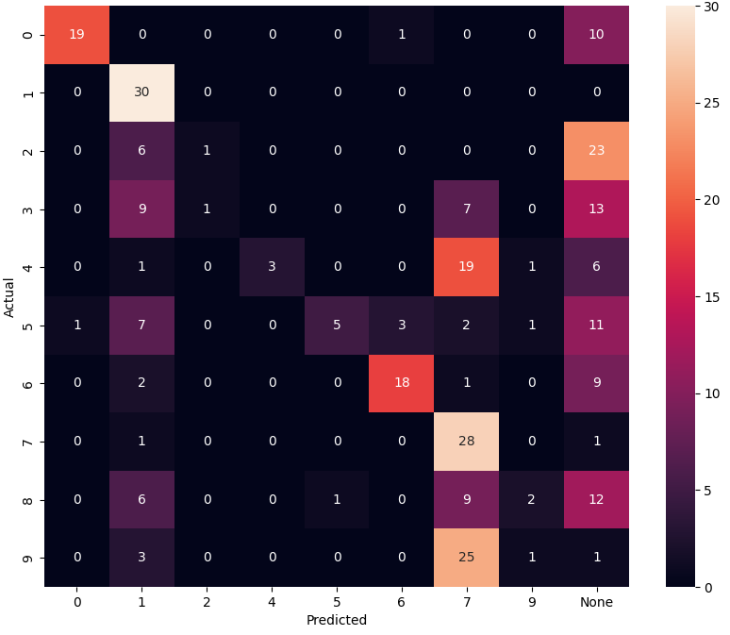

F1_score (train): 0.7021 F1_score (test): 0.35

30 нейронов

1. nn = **30**, n_train = 1000, n_test = 300, k = 0.999, tau_const = 3.5,

g_const = 3.1/ni(train), 3.5/ni(clf), 3.7/ni(test), learning_rate = 0.25

Training time: 182.5425307750702

Actual number of training set: 78

Number of neurons, reacting to the corresponding image: {'5': 5, '6': 2, '8': 5, '0': 6, '7': 3, '1': 1, '3': 4, '2': 3, '4': 1}

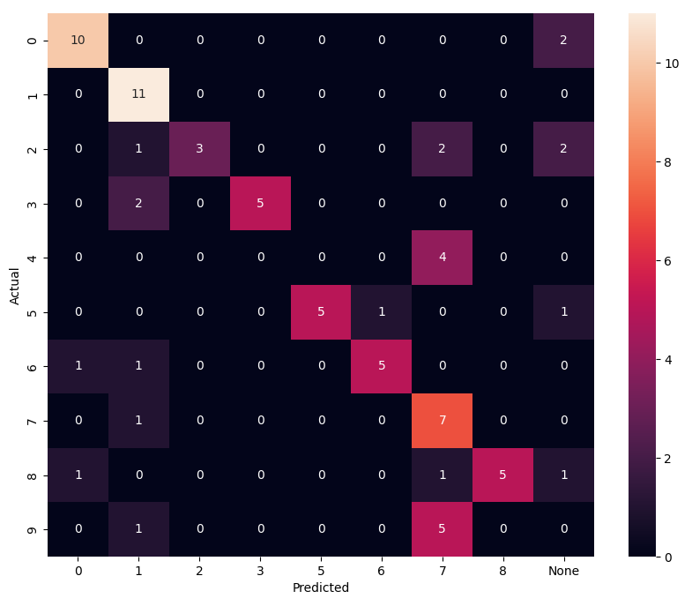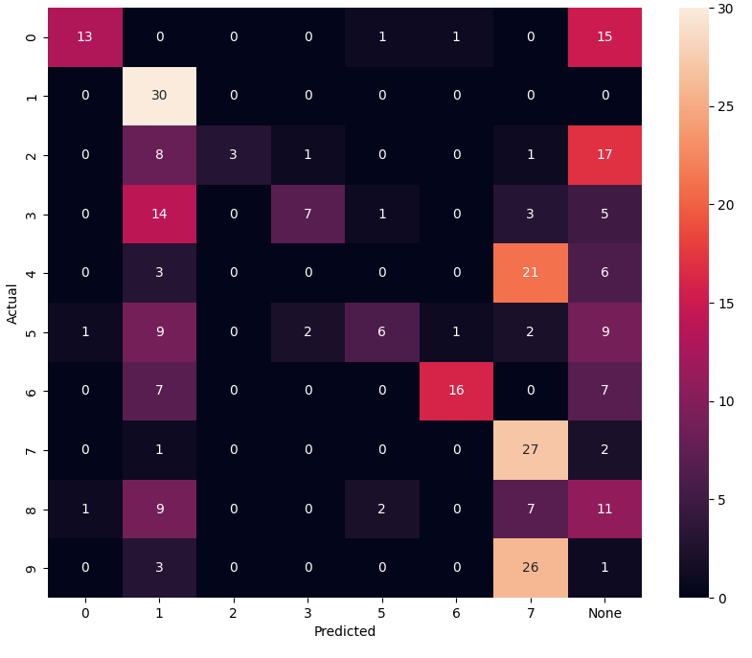

F1_score (train): 0.6538 F1_score (test): 0.34

40 нейронов

1. nn = **40**, n_train = 1000, n_test = 300, k = 0.999, tau_const = 3.5,

g_const = 3.1/ni(train), 3.5/ni(clf), 3.7/ni(test), learning_rate = 0.25

Training time: 335.2424285411835

Actual number of training set: 122

Number of neurons, reacting to the corresponding image: {'8': 6, '1': 1, '2': 5, '7': 5, '9': 3, '0': 8, '3': 4, '4': 1, '5': 5, '6': 2}

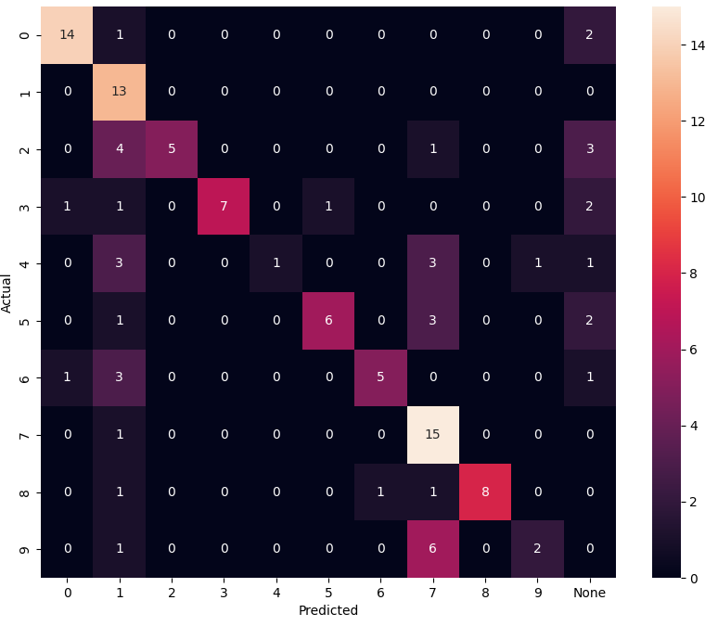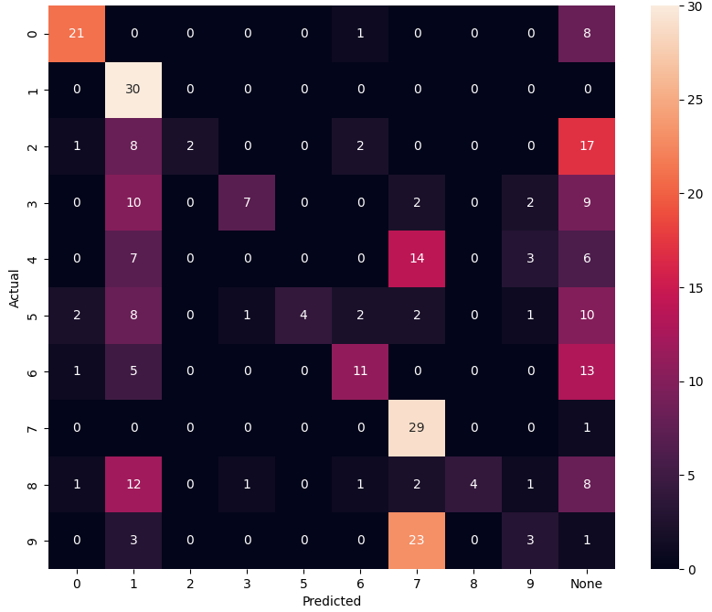

F1_score (train): 0.623 F1_score (test): 0.37

50 нейронов

1. nn = **50**, n_train = 1000, n_test = 300, k = 0.999, tau_const = 3.5,

g_const = 3.1/ni(train), 3.5/ni(clf), 3.7/ni(test), learning_rate = 0.25

Training time: 635.9822239875793

Actual number of training set: 203

Number of neurons, reacting to the corresponding image: {'8': 4, '0': 9, '5': 6, '2': 2, '6': 5, '3': 7, '7': 9, '1': 1, '4': 7}

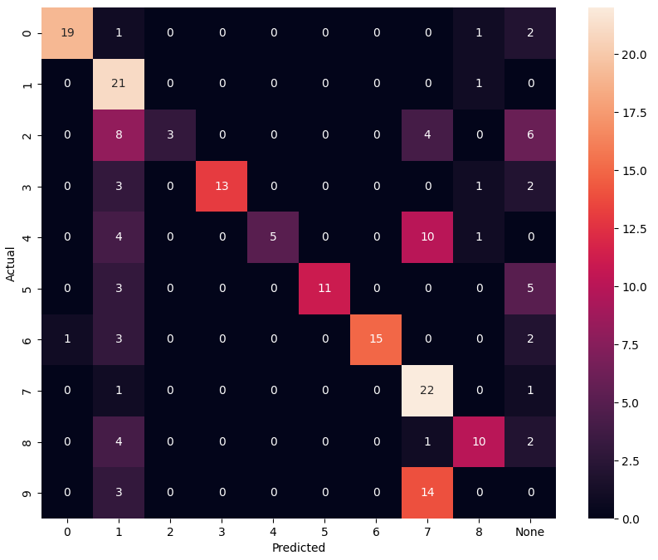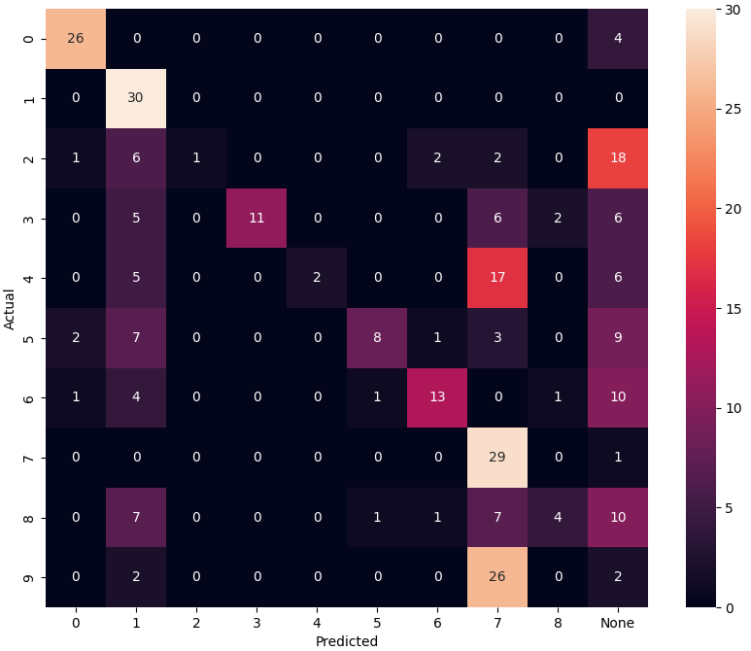

F1_score (train): 0.5862 F1_score (test): 0.4133

60 нейронов

1. nn = **60**, n_train = 1000, n_test = 300, k = 0.999, tau_const = 3.5,

g_const = 3.1/ni(train), 3.5/ni(clf), 3.7/ni(test), learning_rate = 0.25

Training time: 938.0961935520172

Actual number of training set: 256

Number of neurons, reacting to the corresponding image: {'3': 8, '4': 7, '0': 6, '8': 3, '7': 9, '5': 8, '9': 2, '2': 9, '6': 7, '1': 1}

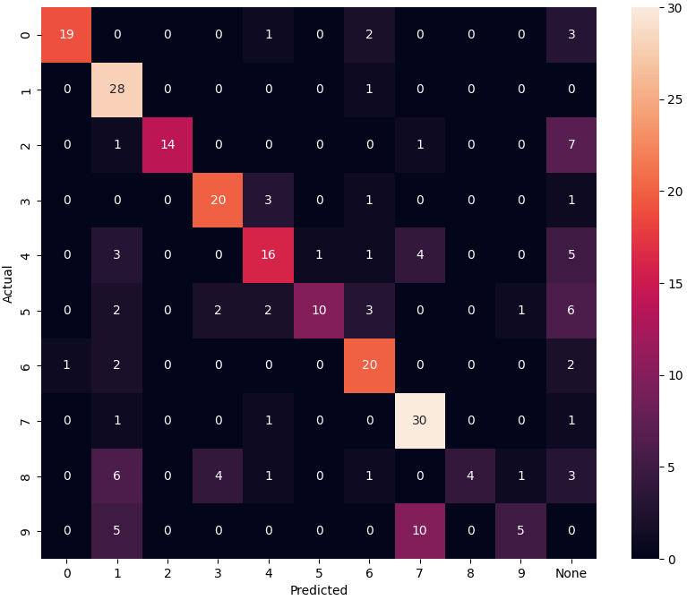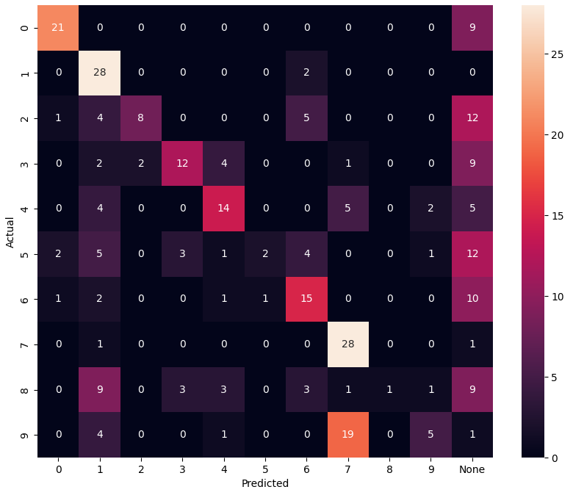

F1_score (train): 0.6484 F1_score (test): 0.4466

70 нейронов

1. nn = **70**, n_train = 1000, n_test = 300, k = 0.999, tau_const = 3.5,

g_const = 3.1/ni(train), 3.5/ni(clf), 3.7/ni(test), learning_rate = 0.25

Training time: 1727.38995718956

Actual number of training set: 404

Number of neurons, reacting to the corresponding image: {'0': 10, '6': 8, '5': 9, '4': 9, '3': 7, '9': 10, '8': 7, '7': 7, '2': 2, '1': 1}

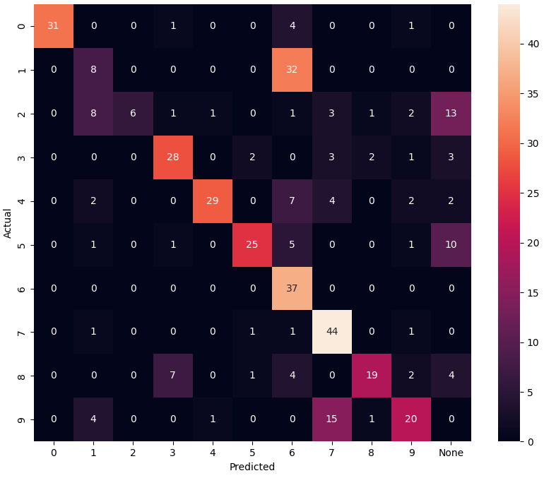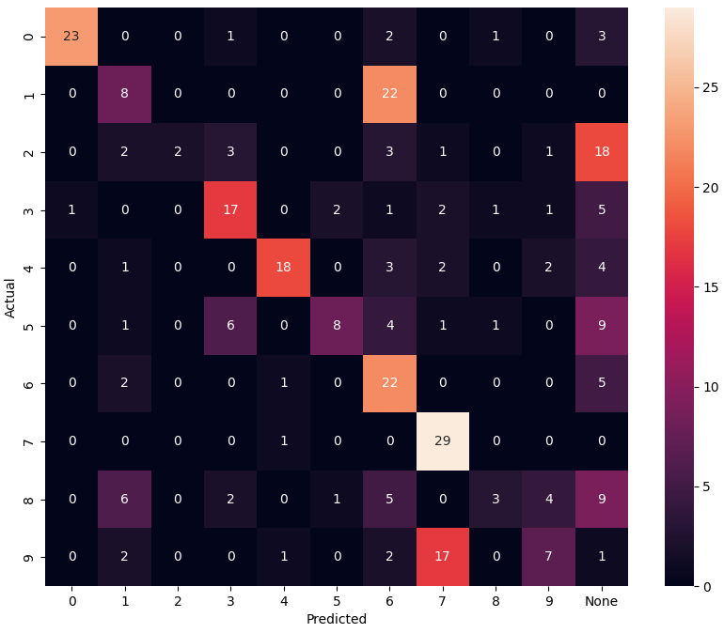

F1_score (train): 0.6114 F1_score (test): 0.4567

80 нейронов

1. nn = **80**, n_train = 1000, n_test = 300, k = 0.999, tau_const = 3.5,

g_const = 3.1/ni(train), 3.5/ni(clf), 3.7/ni(test), learning_rate = 0.25

Training time: 2142.167824745178

Actual number of training set: 379

Number of neurons, reacting to the corresponding image: {'3': 8, '5': 14, '6': 9, '7': 9, '4': 6, '9': 7, '8': 7, '2': 8, '0': 10, '1': 2}

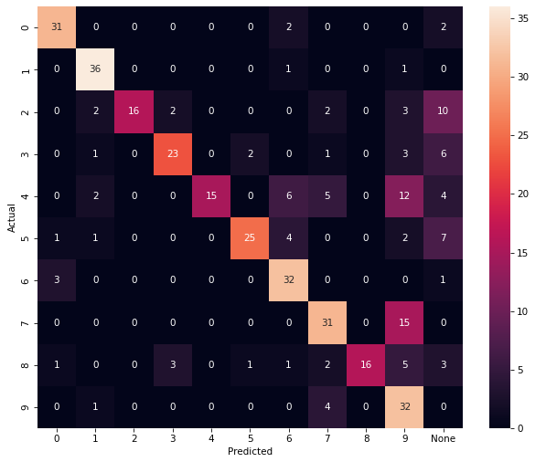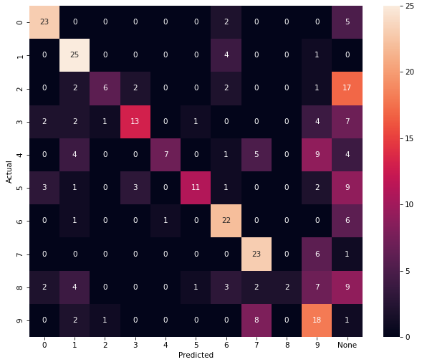

F1_score (train): 0.6781 F1_score (test): 0.5

90 нейронов

1. nn = **90**, n_train = 1000, n_test = 300, k = 0.999, tau_const = 3.5,

g_const = 3.1/ni(train), 3.5/ni(clf), 3.7/ni(test), learning_rate = 0.25

Training time: 3315.13693857193

Actual number of training set: 638

Number of neurons, reacting to the corresponding image: {'5': 9, '2': 8, '7': 11, '8': 13, '4': 8, '3': 8, '0': 14, '6': 9, '9': 7, '1': 3}

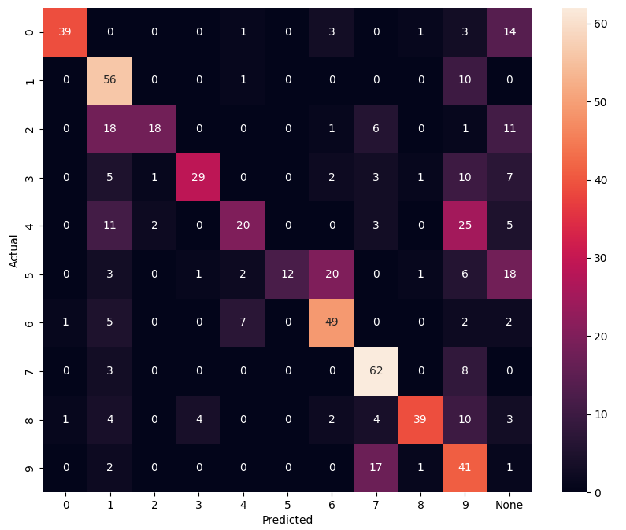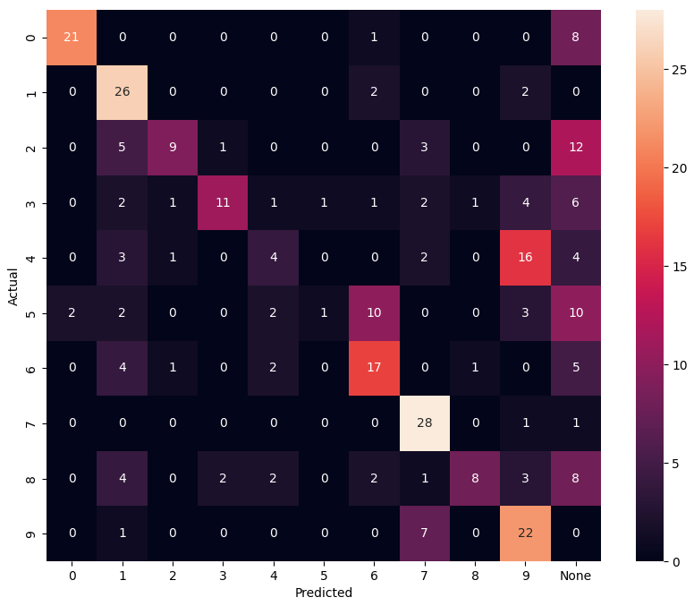

F1_score (train): 0.5721 F1_score (test): 0.49

100 нейронов

1. nn = **100**, n_train = 1000, n_test = 300, k = 0.999, tau_const = 3.5,

g_const = 3.1/ni(train), 3.5/ni(clf), 3.7/ni(test), learning_rate = 0.25

Training time: 3273.6716368198395

Actual number of training set: 588

Number of neurons, reacting to the corresponding image:{'7': 8, '4': 16, '6': 11, '5': 11, '3': 10, '0': 12, '2': 11, '9': 9, '1': 1, '8': 11}

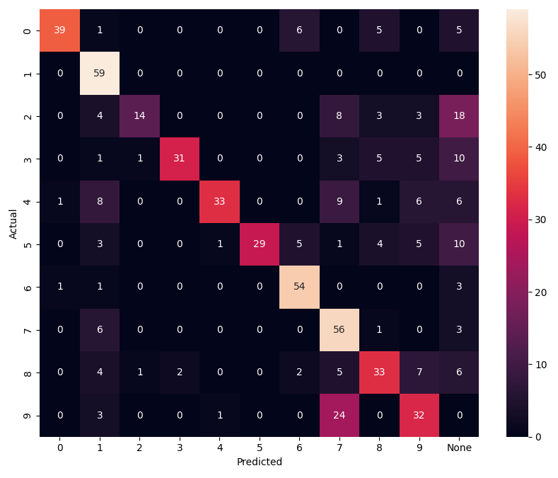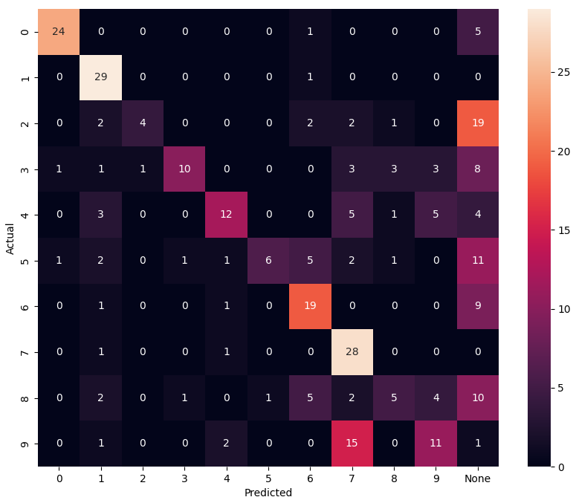

F1_score (train): 0.6463 F1_score (test): 0.4933

110 нейронов

1. nn = **110**, n_train = 1000, n_test = 300, k = 0.999, tau_const = 3.5,

g_const = 3.1/ni(train), 3.5/ni(clf), 3.7/ni(test), learning_rate = 0.25

Training time: 5549.736858844757

Actual number of training set: 752

Number of neurons, reacting to the corresponding image: {'5': 16, '2': 7, '0': 17, '4': 10, '3': 11, '6': 8, '7': 9, '9': 18, '8': 13, '1': 1}

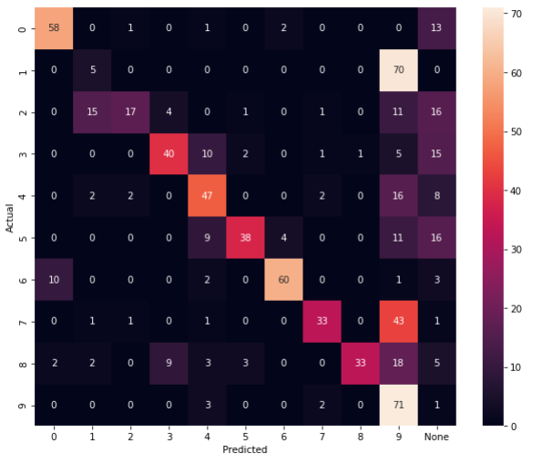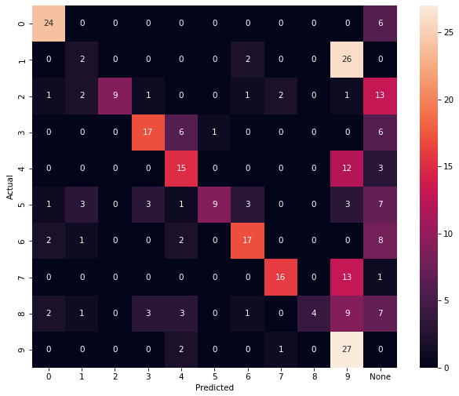

F1_score (train): 0.5346 F1_score (test): 0.4667

120 нейронов

1. nn = **120**, n_train = 1000, n_test = 300, k = 0.999, tau_const = 3.5,

g_const = 3.1/ni(train), 3.5/ni(clf), 3.7/ni(test), learning_rate = 0.25

Training time: 8351.285395860672

Actual number of training set: 901

Number of neurons, reacting to the corresponding image: {'9': 13, '8': 13, '7': 7, '2': 15, '3': 15, '6': 14, '0': 18, '5': 15, '4': 9, '1': 1}

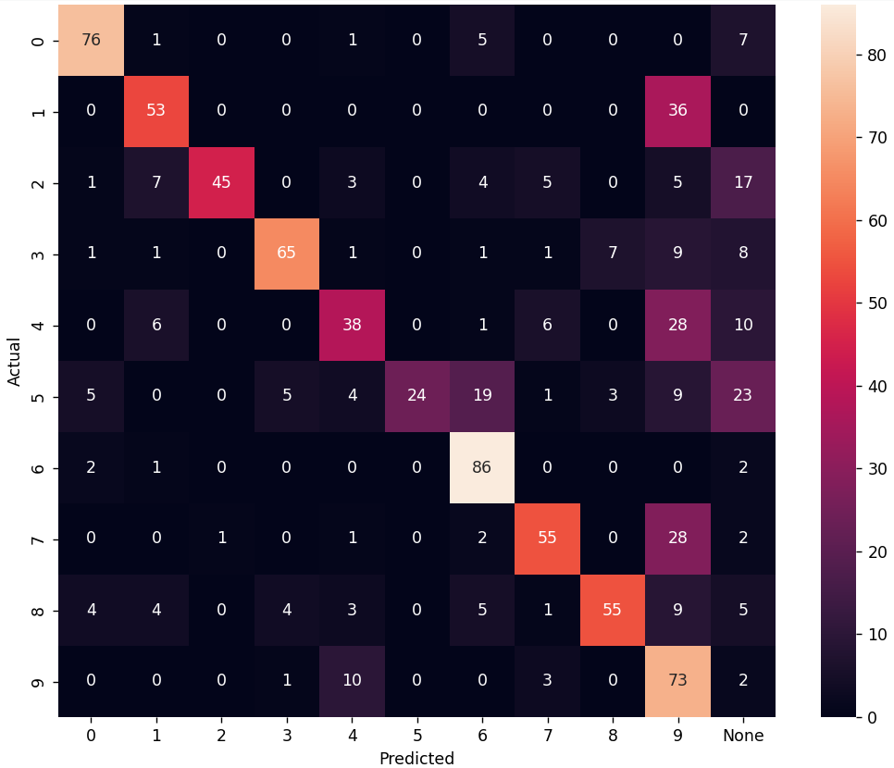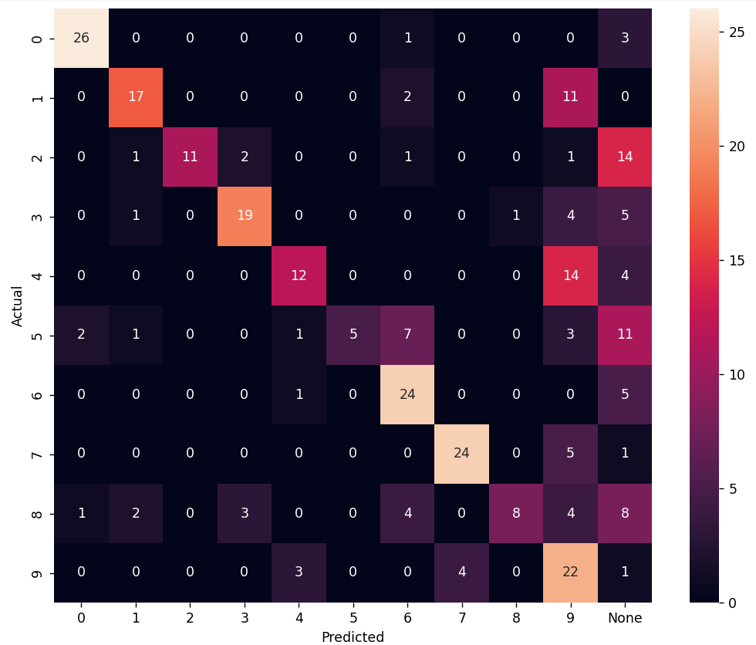

F1_score (train): 0.6326 F1_score (test): 0.56

130 нейронов

1. nn = **130**, n_train = 1000, n_test = 300, k = 0.999, tau_const = 3.5,

g_const = 3.1/ni(train), 3.5/ni(clf), 3.7/ni(test), learning_rate = 0.25

Training time: 8064.663451433182

Actual number of training set: 847

Number of neurons, reacting to the corresponding image: {'4': 14, '8': 10, '5': 16, '0': 18, '3': 19, '2': 18, '1': 3, '9': 11, '6': 14, '7': 7}

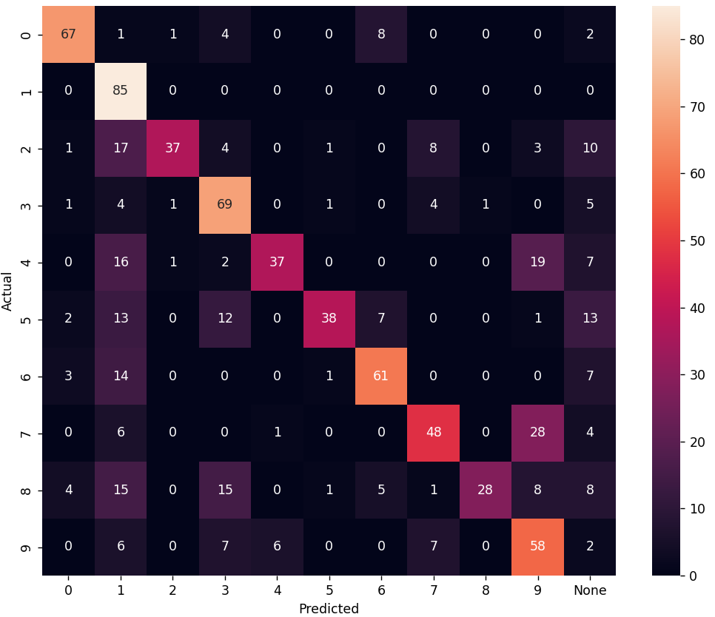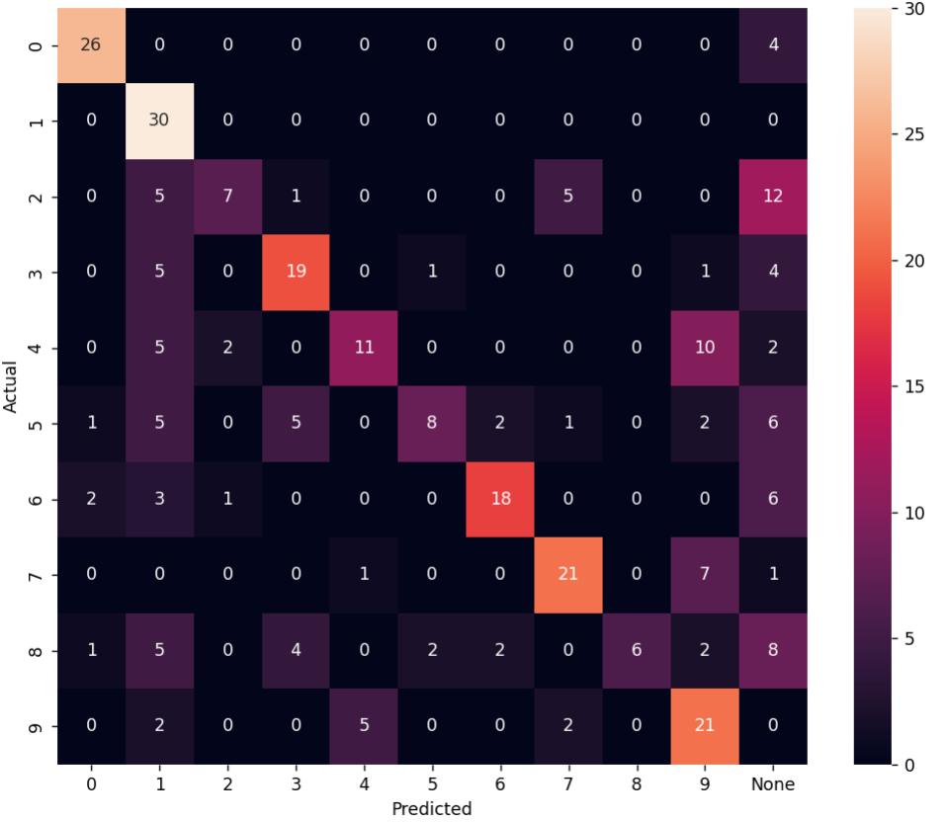

F1_score (train): 0.6233 F1_score (test): 0.5567

140 нейронов

1. nn = **140**, n_train = 1000, n_test = 300, k = 0.999, tau_const = 3.5,

g_const = 3.1/ni(train), 3.5/ni(clf), 3.7/ni(test), learning_rate = 0.25

Training time: 10173.10372543335

Actual number of training set: 1000

Number of neurons, reacting to the corresponding image: {'8': 15, '2': 18, '4': 16, 'None': 15, '0': 16, '7': 9, '5': 19, '9': 7, '6': 13, '3': 11, '1': 1}

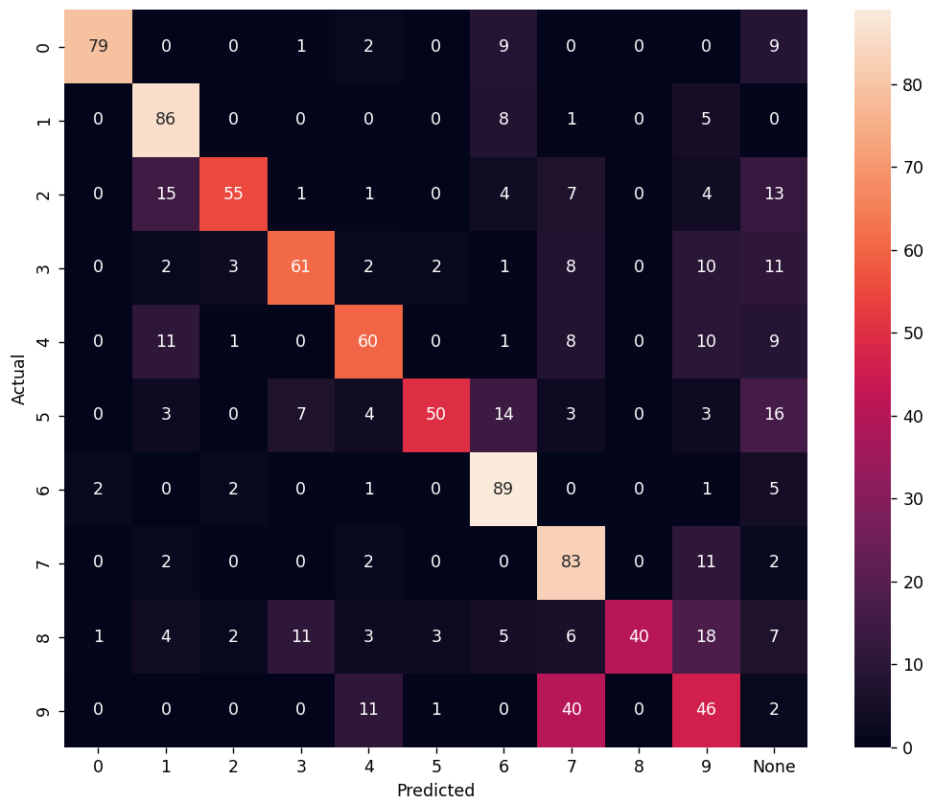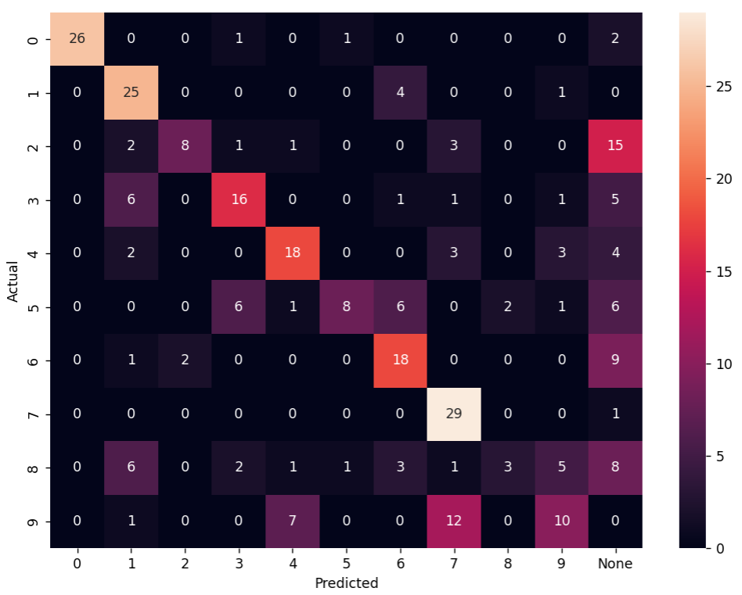

F1_score (train): 0.649 F1_score (test): 0.5367

150 нейронов

1. nn = **150**, n_train = 1000, n_test = 300, k = 0.999, tau_const = 3.5,

g_const = 3.1/ni(train), 3.5/ni(clf), 3.7/ni(test), learning_rate = 0.25

Training time: 10904.928130149841

Actual number of training set: 1000

Number of neurons, reacting to the corresponding image: {'2': 25, '0': 14, '3': 15, '8': 14, '5': 14, '9': 8, 'None': 29, '4': 11, '6': 10, '7': 8, '1': 2}

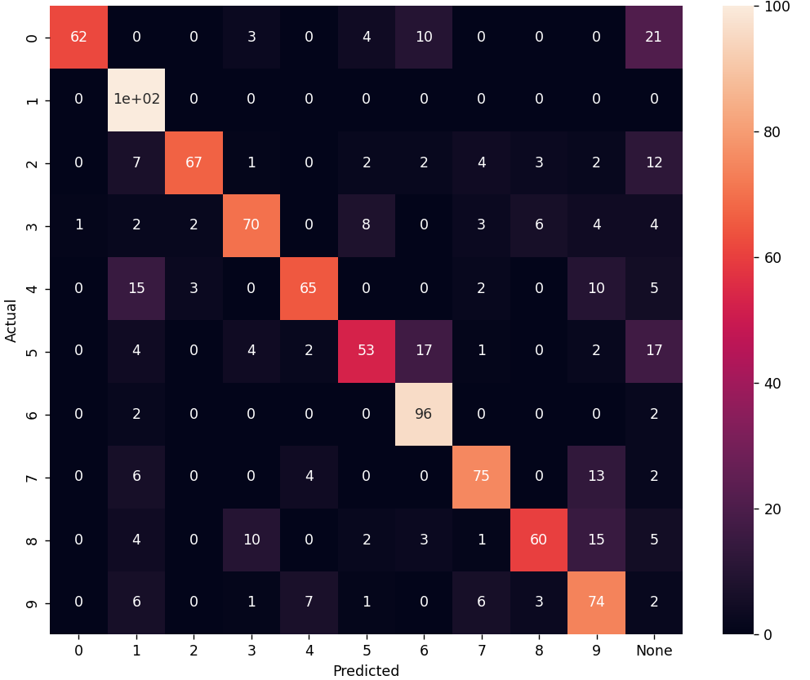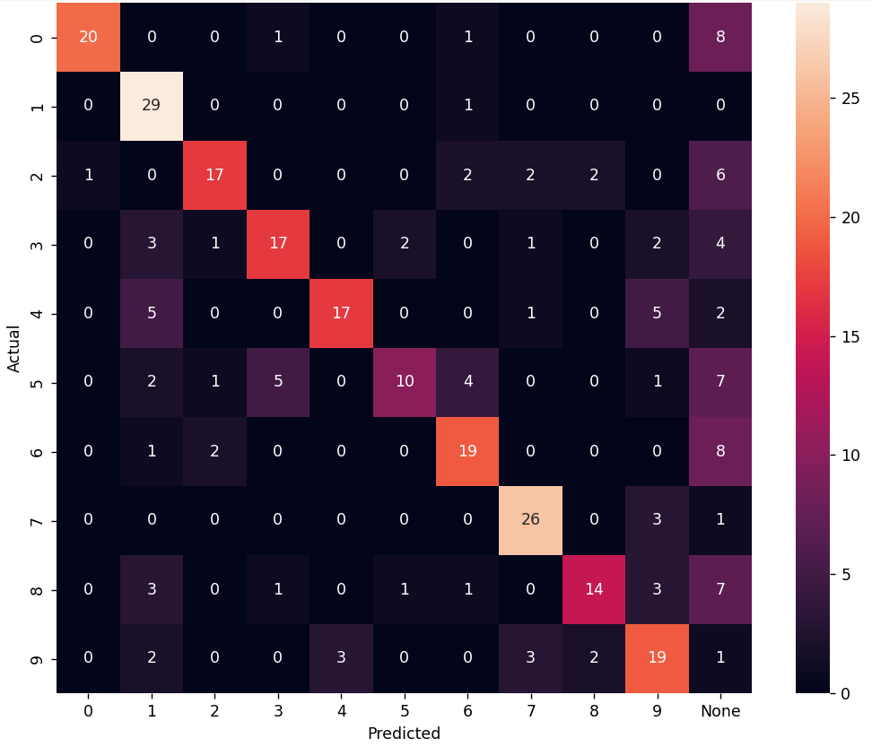

F1_score (train): 0.722 F1_score (test): 0.6267

160 нейронов

1. nn = **160**, n_train = 3000, n_test = 300, k = 0.999, tau_const = 3.5,

g_const = 3.1/ni(train), 3.5/ni(clf), 3.7/ni(test), learning_rate = 0.25

Training time: 15677.193243980408

Actual number of training set: 1290

Number of neurons, reacting to the corresponding image: {'4': 16, '3': 25, '0': 15, '6': 20, '8': 19, '9': 18, '2': 18, '5': 17, '1': 3, '7': 9}

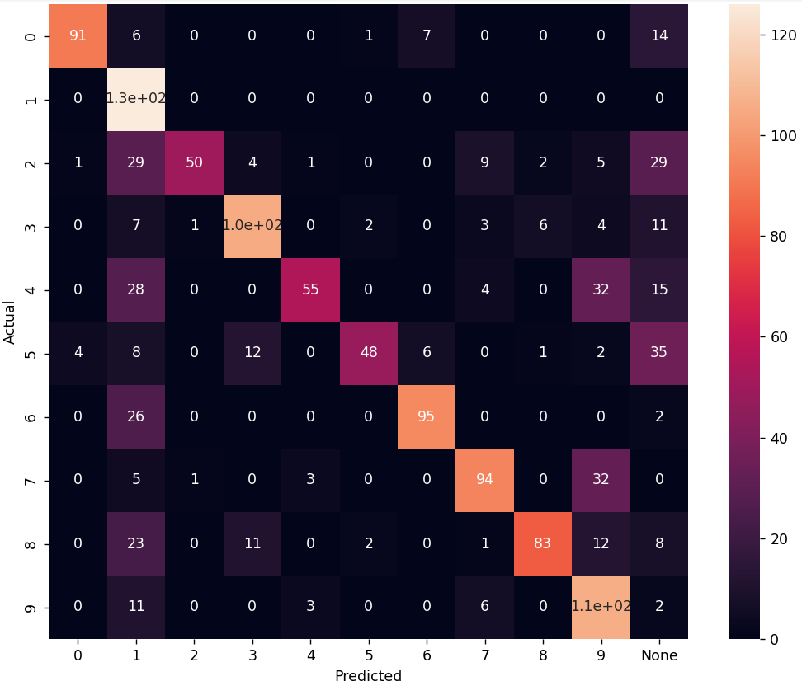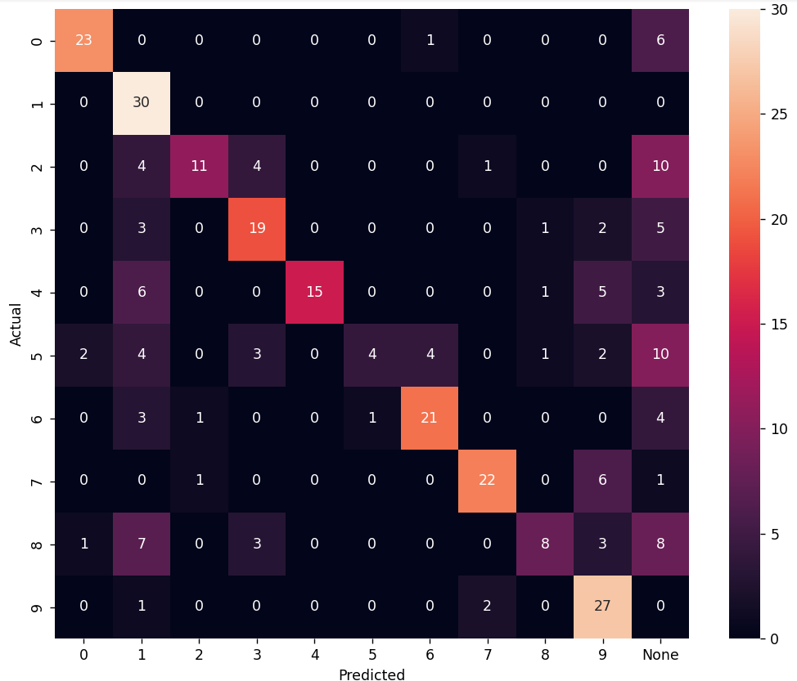

F1_score (train): 0.6612 F1_score (test): 0.6

170 нейронов

1. nn = **170**, n_train = 3000, n_test = 300, k = 0.999, tau_const = 3.5,

g_const = 3.1/ni(train), 3.5/ni(clf), 3.7/ni(test), learning_rate = 0.25

Training time: 23499.82284450531

Actual number of training set: 1391

Number of neurons, reacting to the corresponding image: {'0': 17, '4': 21, '1': 5, '5': 16, '3': 23, '8': 21, '2': 23, '9': 13, '6': 21, '7': 10}

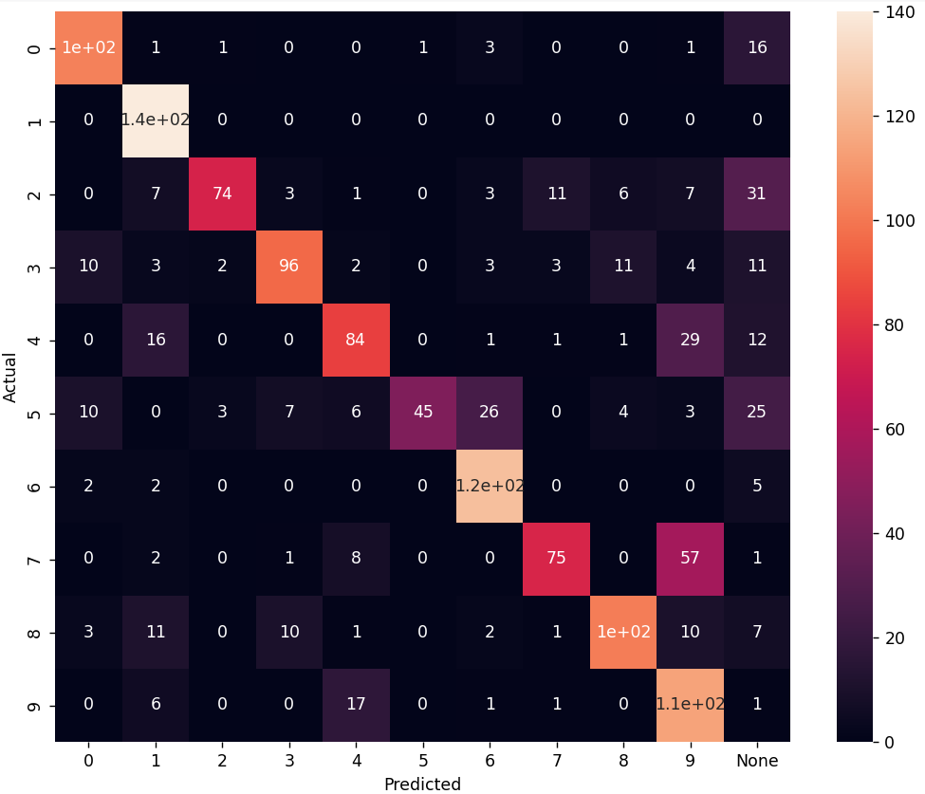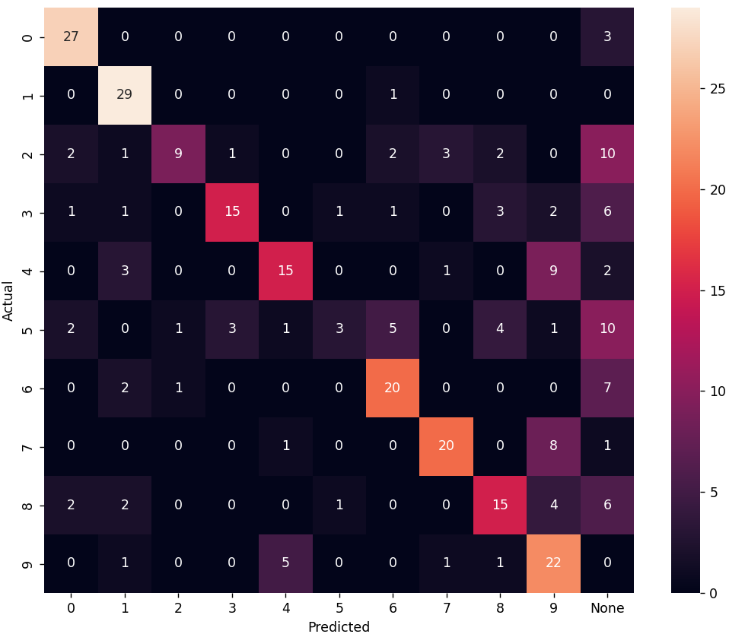

F1_score (train): 0.688 F1_score (test): 0.5833

180 нейронов

1. nn = **180**, n_train = 3000, n_test = 300, k = 0.999, tau_const = 3.5,

g_const = 3.1/ni(train), 3.5/ni(clf), 3.7/ni(test), learning_rate = 0.25

Training time: 14916.605306148529

Actual number of training set: 1493

Number of neurons, reacting to the corresponding image: {'9': 16, '6': 18, '2': 23, '5': 18, '0': 33, '7': 10, '8': 17, '3': 21, '4': 19, '1': 5}

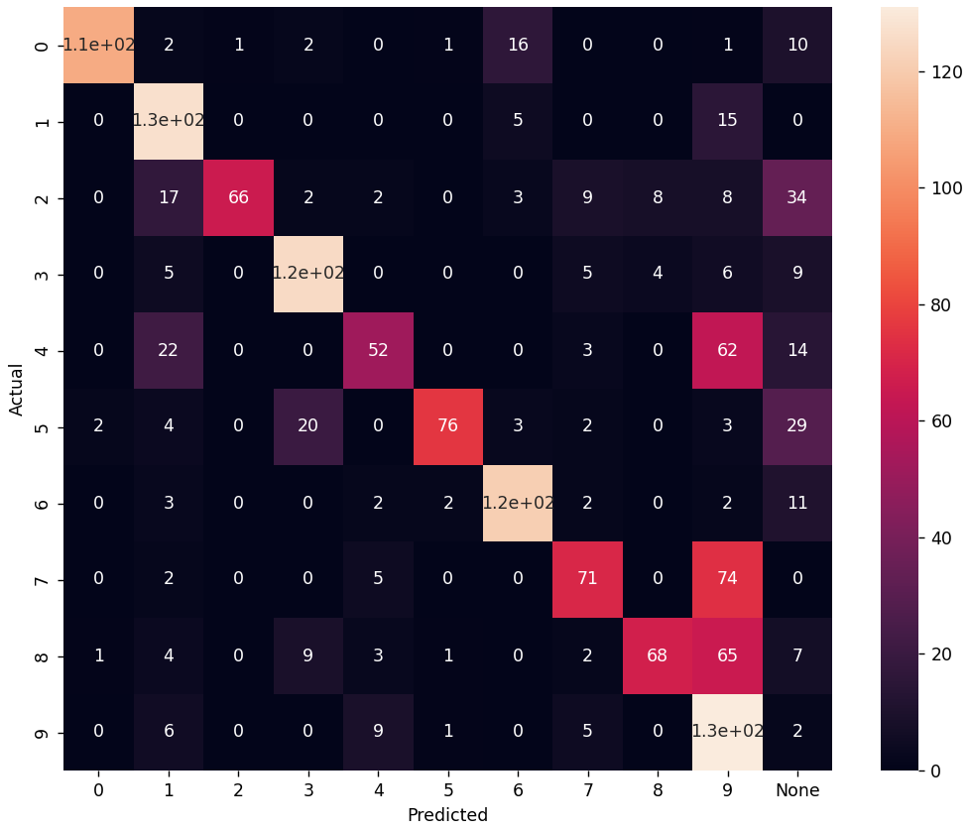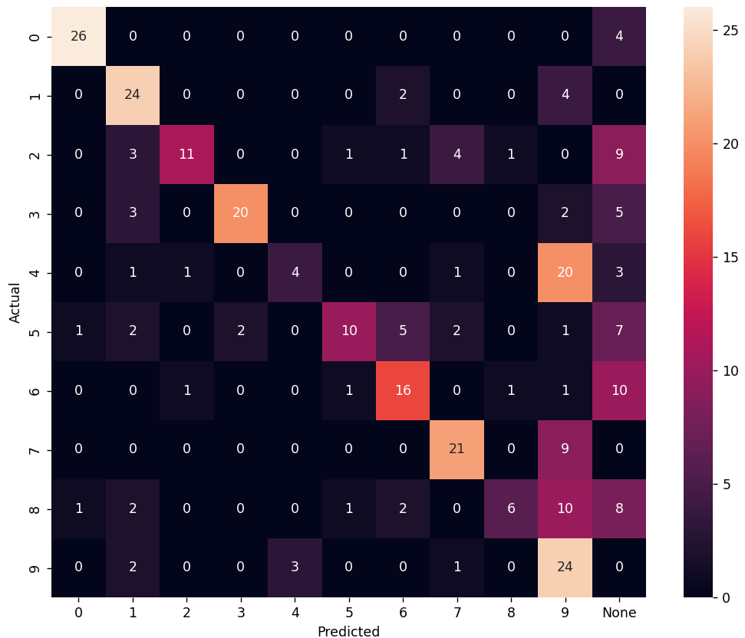

F1_score (train): 0.6336 F1_score (test): 0.54

190 нейронов

1. nn = **190**, n_train = 3000, n_test = 300, k = 0.999, tau_const = 3.5,

g_const = 3.1/ni(train), 3.5/ni(clf), 3.7/ni(test), learning_rate = 0.25

Training time: 16920.599972724915

Actual number of training set: 1730

Number of neurons, reacting to the corresponding image: {'3': 23, '6': 14, '0': 30, '2': 25, '7': 12, '4': 17, '8': 27, '9': 17, '1': 3, '5': 22}

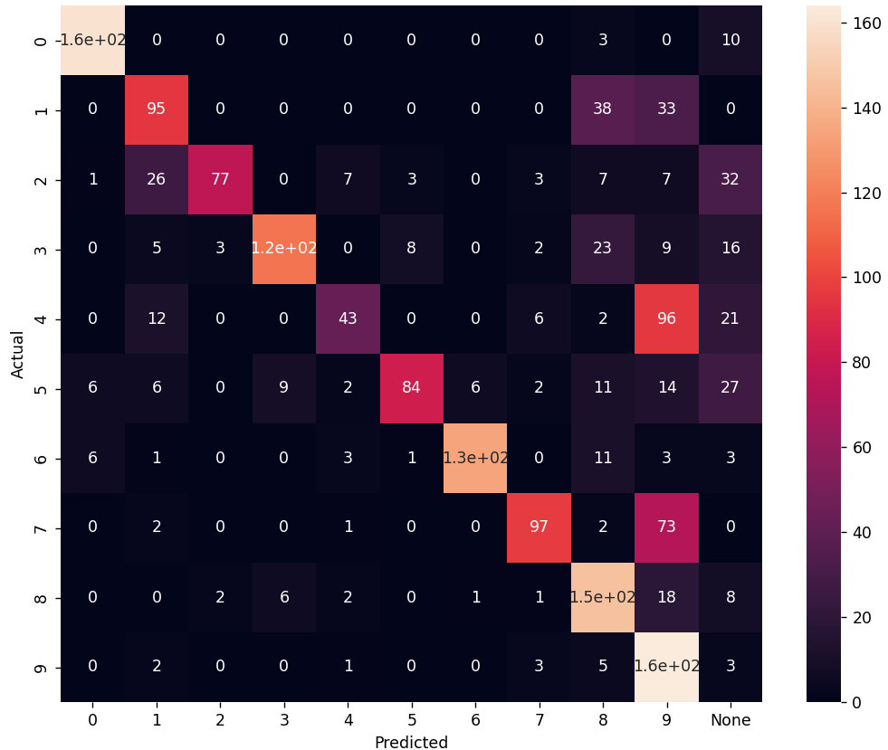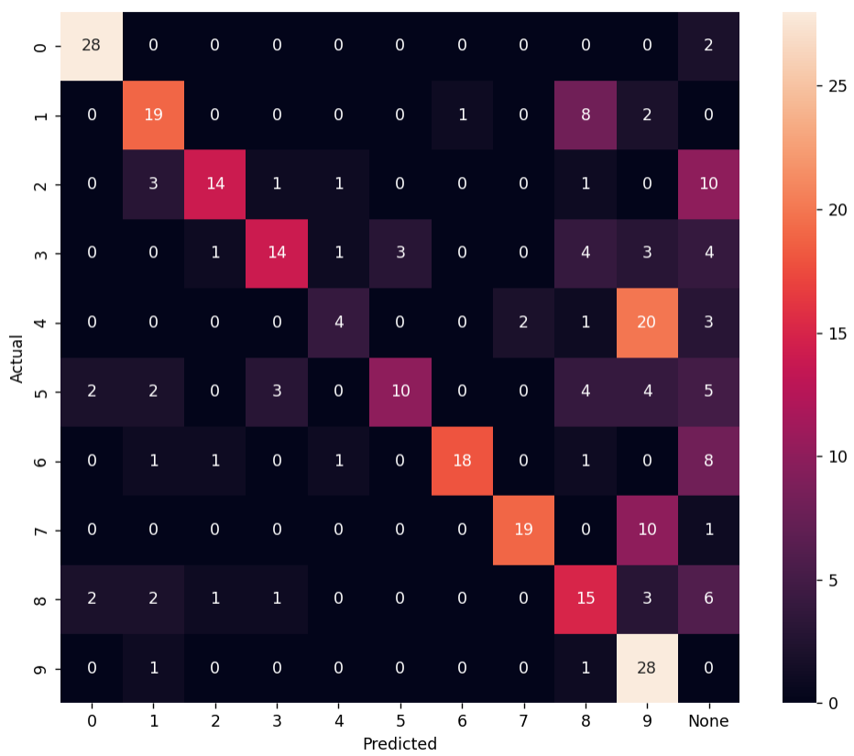

F1_score (train): 0.6451 F1_score (test): 0.5633

200 нейронов

1. nn = **200**, n_train = 3000, n_test = 300, k = 0.999, tau_const = 3.5,

g_const = 3.1/ni(train), 3.5/ni(clf), 3.7/ni(test), learning_rate = 0.25

Training time: 24790.93046450615

Actual number of training set: 1911

Number of neurons, reacting to the corresponding image: {'8': 26, '0': 22, '3': 30, '7': 13, '2': 27, '5': 20, '4': 22, '9': 21, '6': 16, '1': 3}

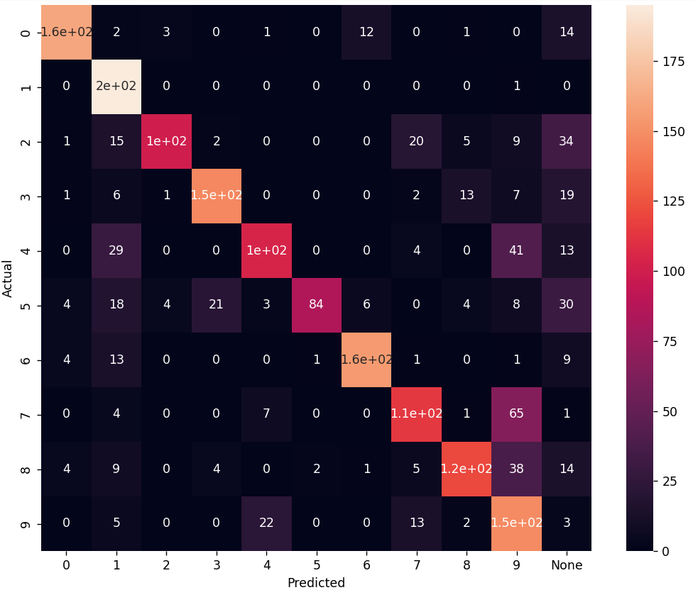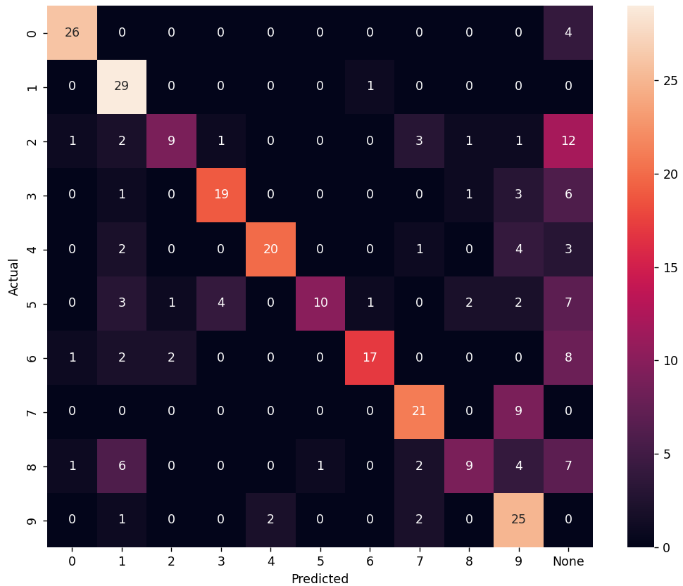

F1_score (train): 0.6949 F1_score (test): 0.6167

210 нейронов

1. nn = **210**, n_train = 3000, n_test = 300, k = 0.999, tau_const = 3.5,

g_const = 3.1/ni(train), 3.5/ni(clf), 3.7/ni(test), learning_rate = 0.25

Training time: 22660.43066596985

Actual number of training set: 2074

Number of neurons, reacting to the corresponding image: {'8': 28, '9': 17, '3': 21, '7': 19, '4': 31, '0': 28, '2': 29, '5': 21, '6': 14, '1': 2}

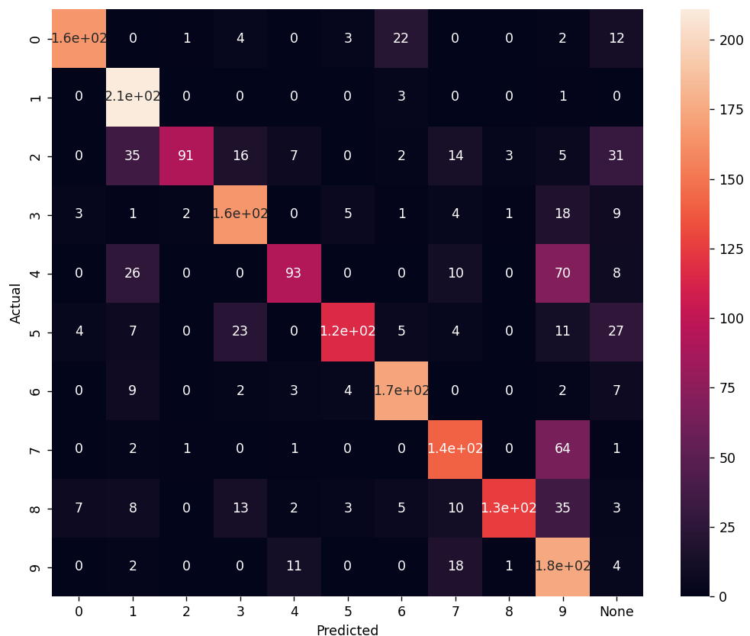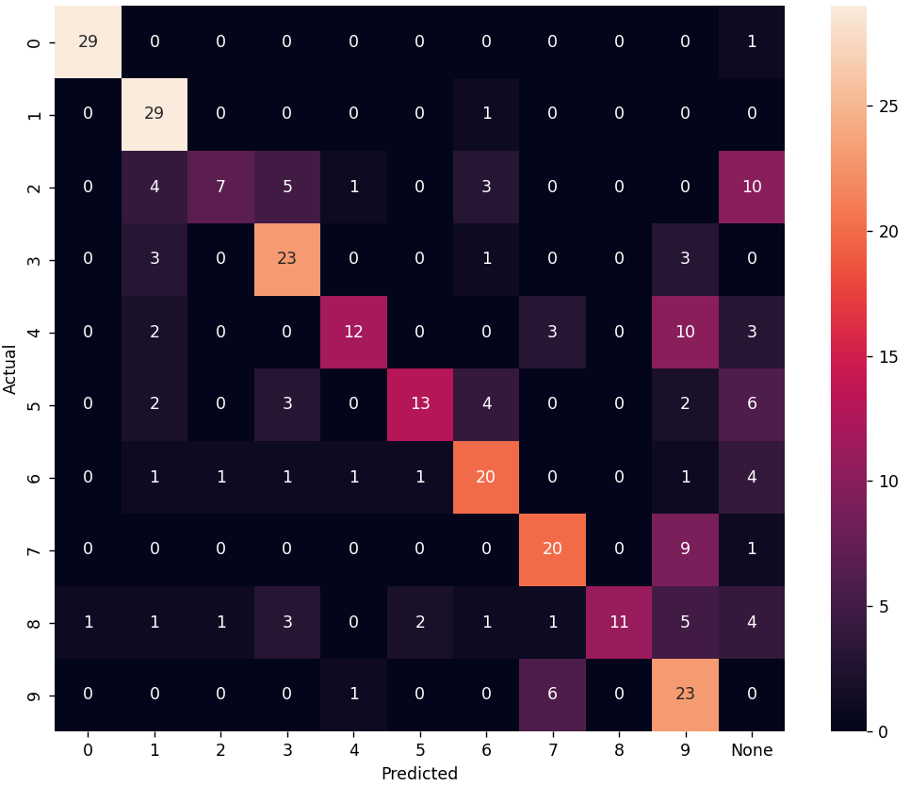

F1_score (train): 0.702 F1_score (test): 0.6233

230 нейронов

1. nn = **230**, n_train = 3000, n_test = 300, k = 0.999, tau_const = 3.5,

g_const = 3.1/ni(train), 3.5/ni(clf), 3.7/ni(test), learning_rate = 0.25

Training time: 22110.465005874634

Actual number of training set: 2318

Number of neurons, reacting to the corresponding image: {'9': 21, '2': 39, '3': 25, '0': 33, '6': 24, '7': 16, '5': 29, '8': 23, '4': 18, '1': 2}

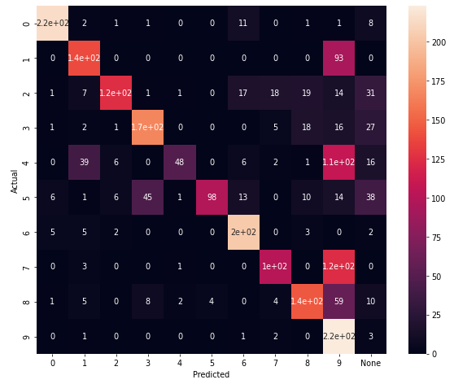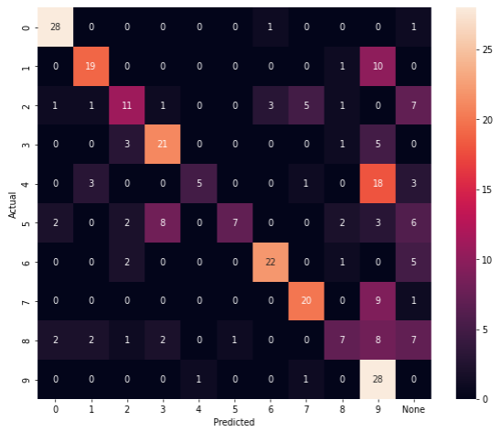

F1_score (train): 0.6316 F1_score (test): 0.56

250 нейронов

1. nn = **250**, n_train = 3000, n_test = 300, k = 0.999, tau_const = 3.5,

g_const = 3.1/ni(train), 3.5/ni(clf), 3.7/ni(test), learning_rate = 0.25

Training time: 38675.63662457466

Actual number of training set: 2422

Number of neurons, reacting to the corresponding image: {'5': 34, '6': 29, '3': 28, '8': 23, '9': 16, '4': 29, '0': 36, '2': 34, '7': 17, '1': 4}

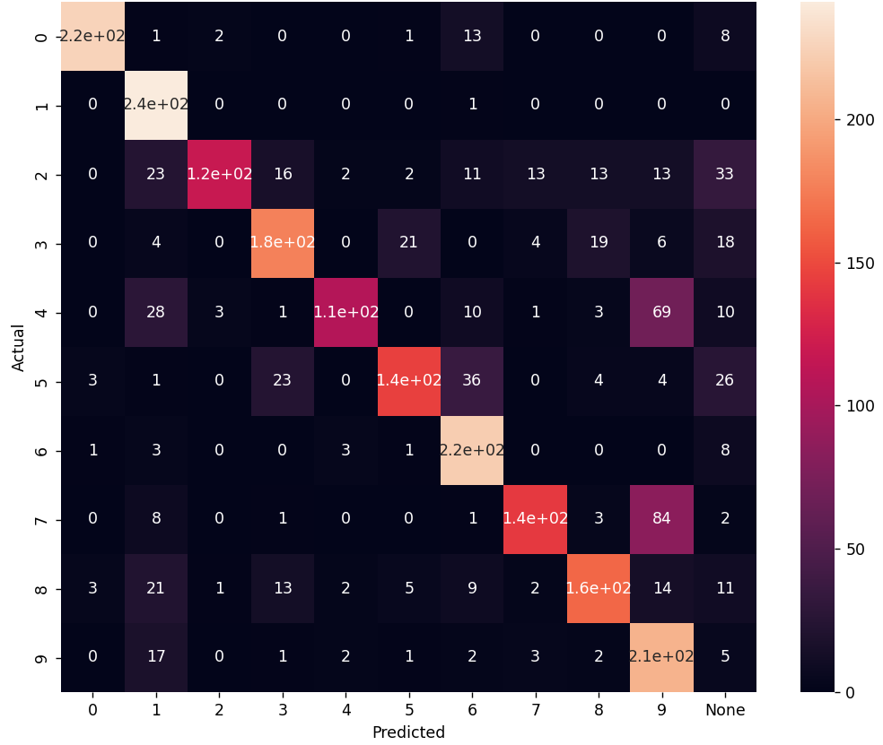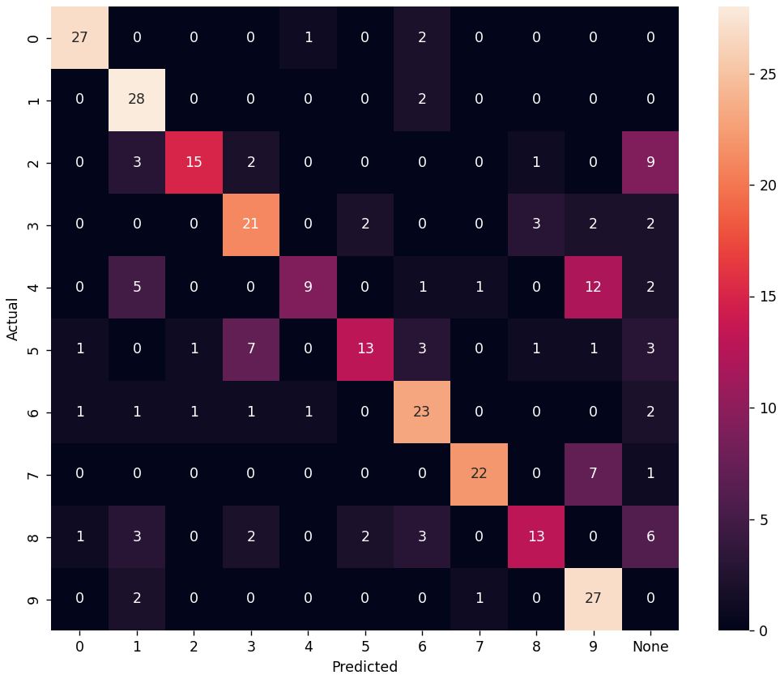

F1_score (train): 0.7213 F1_score (test): 0.66

270 нейронов

1. nn = **270**, n_train = 3000, n_test = 300, k = 0.999, tau_const = 3.5,

g_const = 3.1/ni(train), 3.5/ni(clf), 3.7/ni(test), learning_rate = 0.25

Training time:

Actual number of training set:

Number of neurons, reacting to the corresponding image:



F1_score (train): 0. F1_score (test): 0.

280 нейронов

1. nn = **280**, n_train = 3000, n_test = 300, k = 0.999, tau_const = 3.5,

g_const = 3.1/ni(train), 3.5/ni(clf), 3.7/ni(test), learning_rate = 0.25

Training time: 47968.57797527313

Actual number of training set: 2940

Number of neurons, reacting to the corresponding image: {'0': 31, '3': 50, '5': 39, '8': 32, '6': 30, '4': 35, '7': 15, '2': 25, '9': 18, '1': 5}

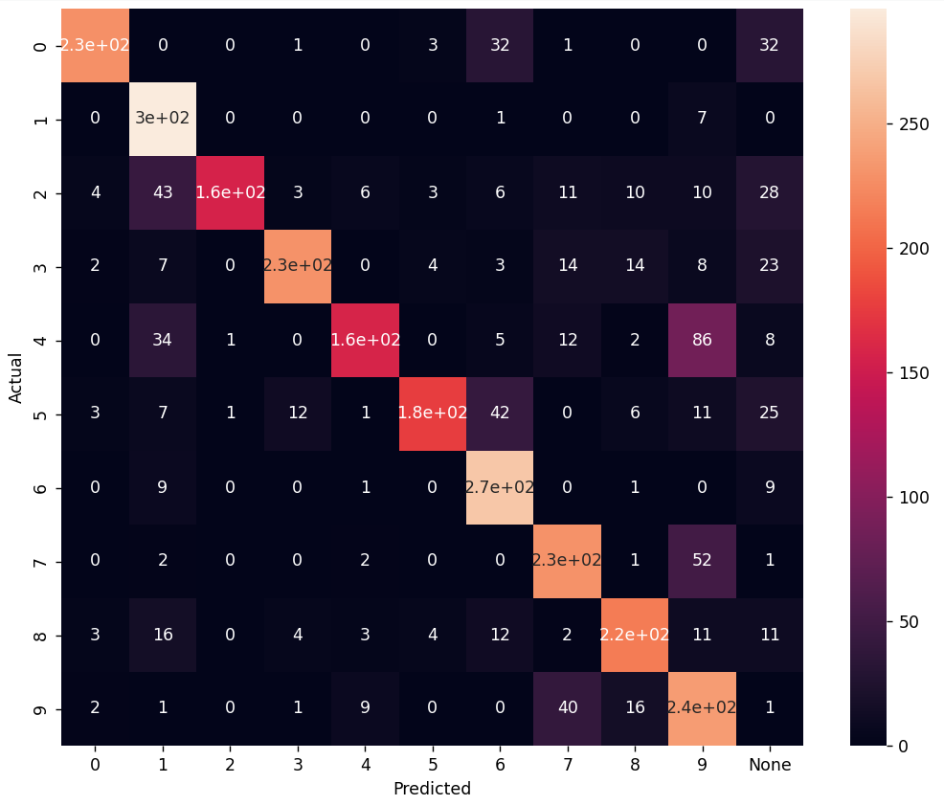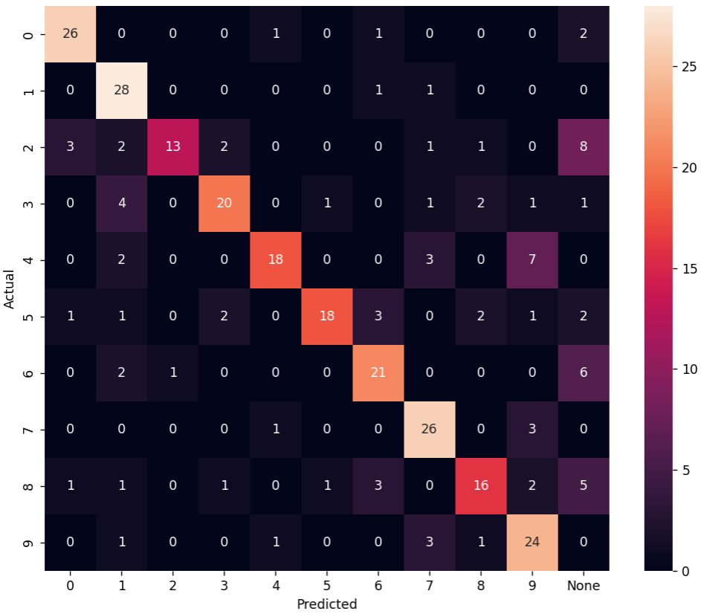

F1_score (train): 0.7463 F1_score (test): 0.7

300 нейронов

1. nn = **300**, n_train = 5000, n_test = 300, k = 0.999, tau_const = 3.5,

g_const = 3.1/ni(train), 3.5/ni(clf), 3.7/ni(test), learning_rate = 0.25

Training time: 47827.090304136276

Actual number of training set: 3244

Number of neurons, reacting to the corresponding image: {'5': 41, '8': 34, '7': 24, '2': 42, '9': 20, '4': 37, '0': 37, '3': 36, '6': 27, '1': 2}

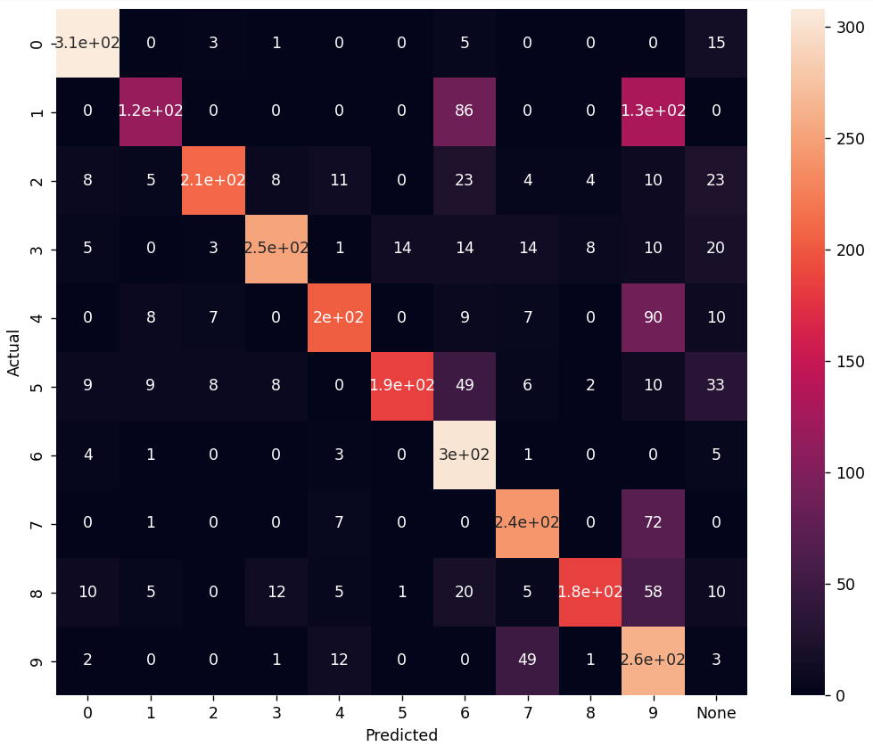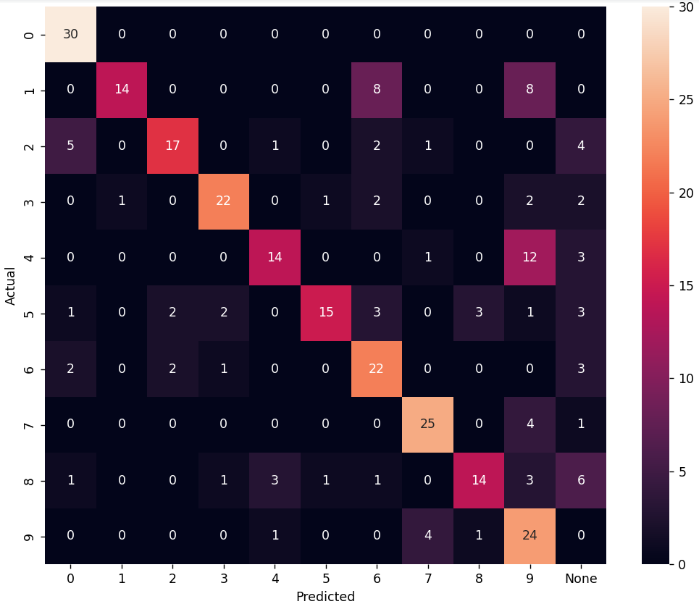

F1_score (train): 0.6985 F1_score (test): 0.6567

320 нейронов

1. nn = **320**, n_train = 5000, n_test = 300, k = 0.999, tau_const = 3.5,

g_const = 3.1/ni(train), 3.5/ni(clf), 3.7/ni(test), learning_rate = 0.25

Training time: 42261.683680057526

Actual number of training set: 3349

Number of neurons, reacting to the corresponding image: {'4': 38, '0': 40, '7': 14, '5': 54, '2': 40, '8': 38, '9': 26, '6': 27, '3': 42, '1': 1}

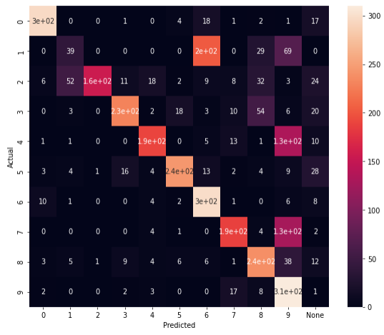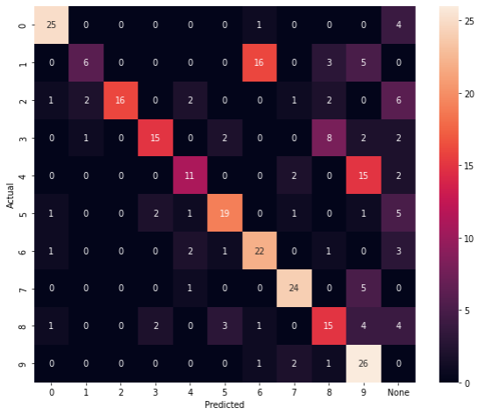

F1_score (train): 0.653 F1_score (test): 0.5967

330 нейронов

1. nn = **330**, n_train = 3000, n_test = 300, k = 0.999, tau_const = 3.5,

g_const = 3.1/ni(train), 3.5/ni(clf), 3.7/ni(test), learning_rate = 0.25

Training time:

Actual number of training set:

Number of neurons, reacting to the corresponding image:



F1_score (train): 0. F1_score (test): 0.

350 нейронов

1. nn = **350**, n_train = 3000, n_test = 300, k = 0.999, tau_const = 3.5,

g_const = 3.1/ni(train), 3.5/ni(clf), 3.7/ni(test), learning_rate = 0.25

Training time:

Actual number of training set:

Number of neurons, reacting to the corresponding image:



F1_score (train): 0. F1_score (test): 0.